Memorandum

To: Mayor and City Council Members
Steve Parker, City Manager

From: Terri Lynn Ruckstuhl, Senior Utilities Engineer

Through: Timothy J. Howe, Director of Utilities and Rick Cortes, Deputy City Manager

Subject: Resolution authorizing the City Manager to enter into an agreement with JM Pipeline, LLC., in the amount of $3,400,000.00 for the construction of the Groundwater Surface Water Loop Project; and declaring an effective date.

Date: January 21, 2025

Historical Background
On November 15, 2022, Council approved an engineering services proposal for the design of approximately 15,500 linear feet (LF) extending from the Hwy. 123 elevated storage tank routing south along Hwy. 123 to Strempel Road turning west, then south and crossing beneath I-10 and connecting to existing water mains on 8th Street and Guadalupe Street near Rio Nogales St. On May 7, 2024, Council awarded a construction contract to Guerra Underground for the 24-inch Water Transmission Main Project which included 6,900 LF of water main originally a part of the Groundwater Surface Water Loop Project.
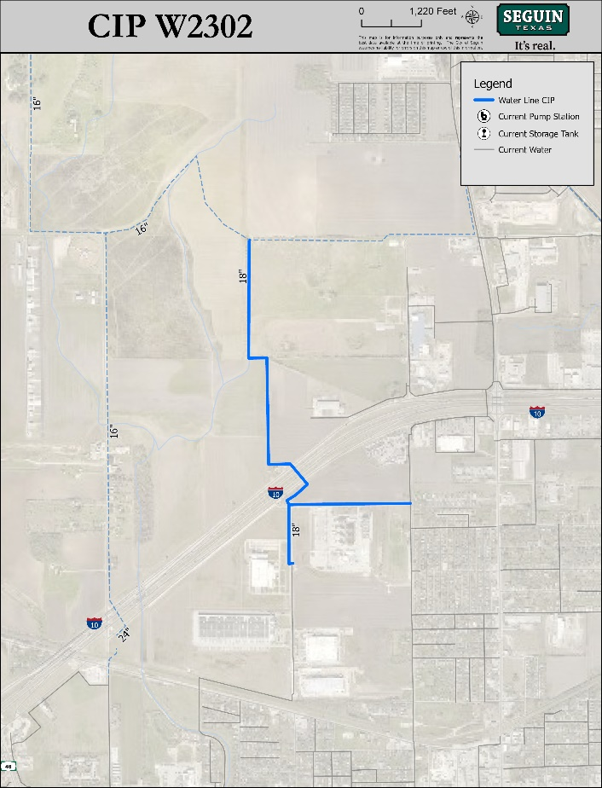
Action Requested
Consider a resolution authorizing the award of a construction contract to install approximately 8,900 LF of 18-inch water main, a pressure-reducing valve and vault, associated electrical work, and other appurtenances.

Procurement Methodology & Funding Source
Seven (7) sealed bids were received at Seguin City Hall on December 17, 2024, at 3:00 P.M. to begin construction. The total bid amounts for the seven bidders ranged from $3,087,627.75 from JM Pipeline, LLC. of Burnet to $4,175,889.50 from M&C Fonseca Construction of Granite Shoals.

Funding for this project has been secured through certificates of obligation.

Staff Recommendation
It is recommended that JM Pipeline, LLC. be awarded a construction contract for $3,087,627.75, plus $312,372.25 in contingencies, for a total not to exceed $3,400,000.00. TRC Engineers conducted reference checks and found that JM Pipeline, LLC. has completed similar projects to the satisfaction of the Owners and Engineers.

The Contractor has a bid bond and will be required to furnish a Standard Form of Agreement, Performance Bond, and Payment Bond to the City. The construction completion period is two hundred and seventy-five (275) consecutive calendar days.

ATTACHMENTS
- Resolution - Groundwater Surface Water Loop Project
- TRC Engineers Bid Evaluation and Award Recommendation Letter

