Memorandum

To: Mayor and City Council Members
Steve Parker, City Manager

From: Terri Lynn Ruckstuhl, Senior Utilities Engineer

Through: Timothy J. Howe, Director of Utilities and Rick Cortes, Deputy City Manager

Subject: Resolution authorizing the City Manager to enter into a professional service agreement with Trihydro Corporation, in the amount of $2,496,000.00 for the construction administration and inspection services on the River Oak Wastewater Improvements Project; and declaring an effective date.

Date: January 21, 2025

Historical Background
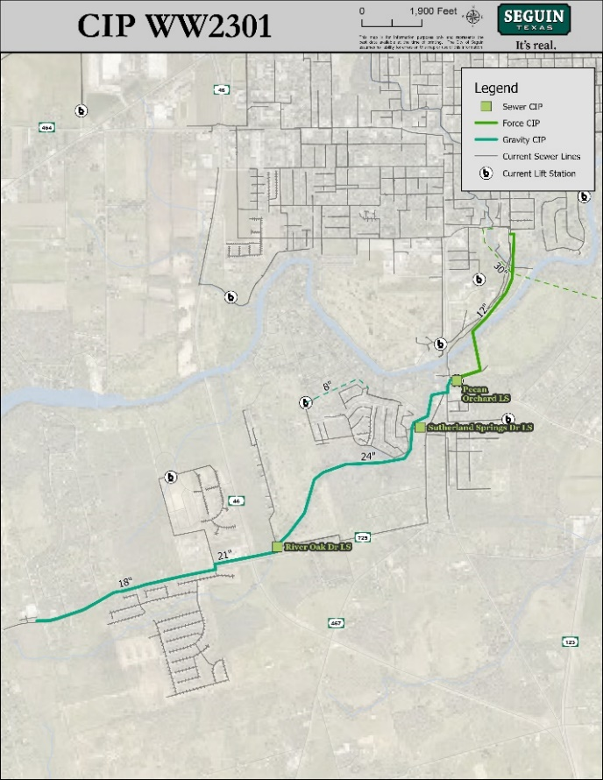
On May 16, 2023, Council approved a professional service agreement with Trihydro Corporation for engineering services related to the River Oak interceptor and Pecan Orchard lift station expansion project to accommodate the increased wastewater demand in the vicinity of FM 725 and SH 46 due to rapid residential and commercial growth in the project area. The scope of work included design plans for the installation of approximately 8,700 linear feet of 24-inch wastewater line, 2,400 linear feet of 21-inch wastewater line, 5,800 linear feet of 18-inch wastewater line, expansion of the existing Pecan Orchard lift station to 6.2 MGD, and installation of approximately 4,700 linear feet of 12-inch sewer force main. Decommissioning the existing River Oak Drive and Sutherland Springs Drive lift stations is also proposed.

Action Requested
Consider a resolution authorizing a professional service agreement award for construction administration and inspection services to the River Oak Wastewater Improvements Project.

Procurement Methodology & Funding Source
Trihydro Corporation provided the City’s Utilities Department with a professional services proposal in the amount of $2,170,000.00 for construction administration and inspection services.

Funding for this project has been secured through certificates of obligation.

Staff Recommendation
It is recommended that Trihydro Corporation be awarded a professional service agreement for construction administration and inspection services in the amount of $2,170,000.00, plus $326,000.00 in contingencies, for a total not to exceed $2,496,000.00.

ATTACHMENTS
- Resolution - Construction Administration and Inspections Services
- TriHydro Construction Administration and Inspections Services Proposal

