Memorandum

To: Mayor and City Council Members
Steve Parker, City Manager

From: Terri Lynn Ruckstuhl, Senior Utilities Engineer

Through: Timothy J. Howe, Director of Utilities, and Rick Cortes, Deputy City Manager

Subject: Resolution authorizing the City Manager to enter into an agreement with Qro Mex Construction Company, Inc. in the amount of $9,878,821.00 for the construction of the River Oak Wastewater Improvements Gravity Main Project; and declaring an effective date.

Date: January 21, 2025

Historical Background
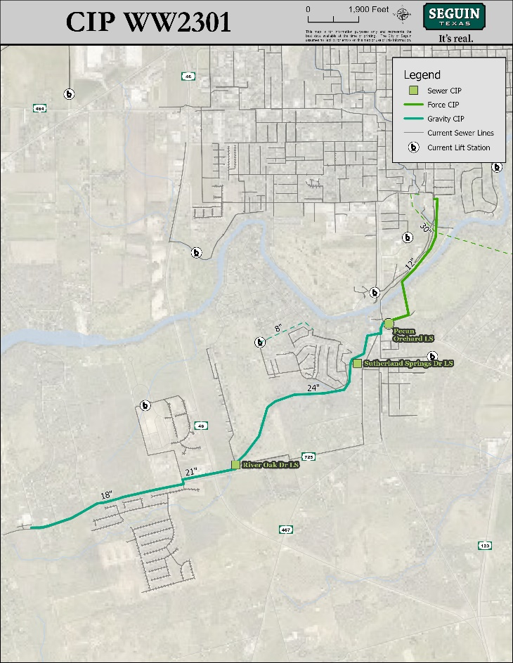
On May 16, 2023, Council approved a professional service agreement with Trihydro Corporation for engineering services related to the River Oak interceptor and Pecan Orchard lift station expansion project to accommodate the increased wastewater demand in the vicinity of FM 725 and SH 46 due to rapid residential and commercial growth in the project area. The scope of work included design plans for the installation of approximately 8,700 linear feet of 24-inch wastewater line, 2,400 linear feet of 21-inch wastewater line, 5,800 linear feet of 18-inch wastewater line, expansion of the existing Pecan Orchard lift station to 6.2 MGD, and installation of approximately 4,700 linear feet of 12-inch sewer force main. Decommissioning the existing River Oak Drive and Sutherland Springs Drive lift stations is also proposed.

Action Requested
Consider a resolution authorizing the award of a construction contract to install approximately 8,852 linear feet (LF) of 24-inch, 18-inch, and 8-inch sewer mains, approximately 7,362 LF of 18-inch sewer main by pipe bursting, decommission two lift stations, and other appurtenances.

Procurement Methodology & Funding Source
Two (2) sealed bids were received at Seguin City Hall on January 7, 2025, at 3:00 P.M. to begin construction. The total bid amounts for the two bidders ranged from $8,978,821.00 from Qro Mex Construction Company, Inc. of Granite Shoals to $9,722,294.66 from Guerra Underground, LLC of Austin.

Funding for this project has been secured through certificates of obligation.

Staff Recommendation
It is recommended that Qro Mex Construction Company, Inc. be awarded a construction contract for $8,978,821.00, plus $900,000.00 in contingencies, for a total not to exceed $9,878,821.00. Trihydro conducted reference checks and found Qro Mex Construction Company, Inc. has completed similar projects to the satisfaction of the Owners and Engineers.

The Contractor has a bid bond and will be required to furnish the city with a Standard Form of Agreement, Performance Bond, and Payment Bond. The construction completion period is three hundred and five (305) consecutive calendar days.

ATTACHMENTS
- Resolution - River Oak Wastewater Improvements Gravity Main Project
- Trihydro Bid Results Evaluation and Award Recommendation Letter

