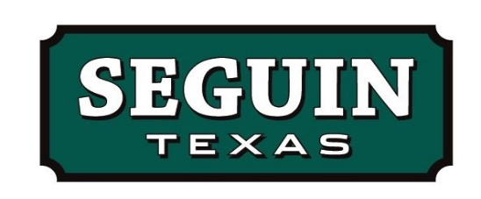

MEMORANDUM

TO: Mayor and City Councilmembers
Steve Parker, City Manager

FROM: Ashley Bruns, Purchasing Manager

DATE: January 21, 2025

RE: 791 Purchasing Cooperative

The 791 Purchasing Cooperative is located in San Antonio, Texas and is governed by their Board of Directors. The 791 Purchasing Cooperative offers best value contracts for goods and services for use by all public and private schools, colleges, universities, cities, counties, and other government entities nationwide.
All awarded contracts through the 791 cooperative meet State of Texas competitive bidding requirements.
Participation in this purchasing cooperative offers substantial savings and best value to participating members. Participation is free for the City.
A resolution authorizing participation and an Interlocal Agreement between the City and the 791 Purchasing Cooperative is required.

